REVIEW-WEEK 21
I/ Look at the picture and the letters. Write the word.
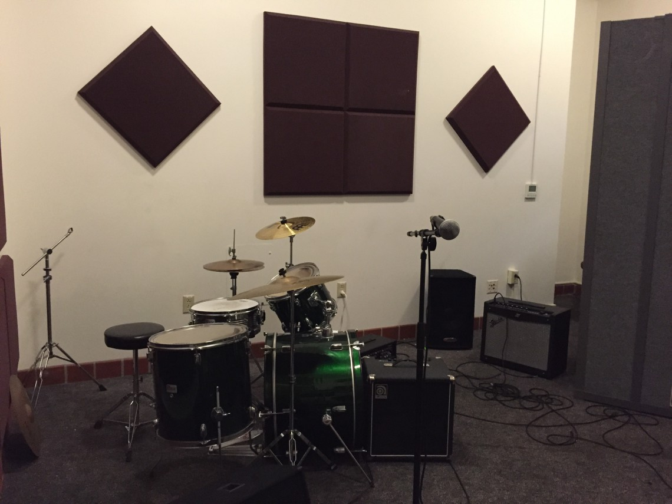
EX: musci rmoo….> music room

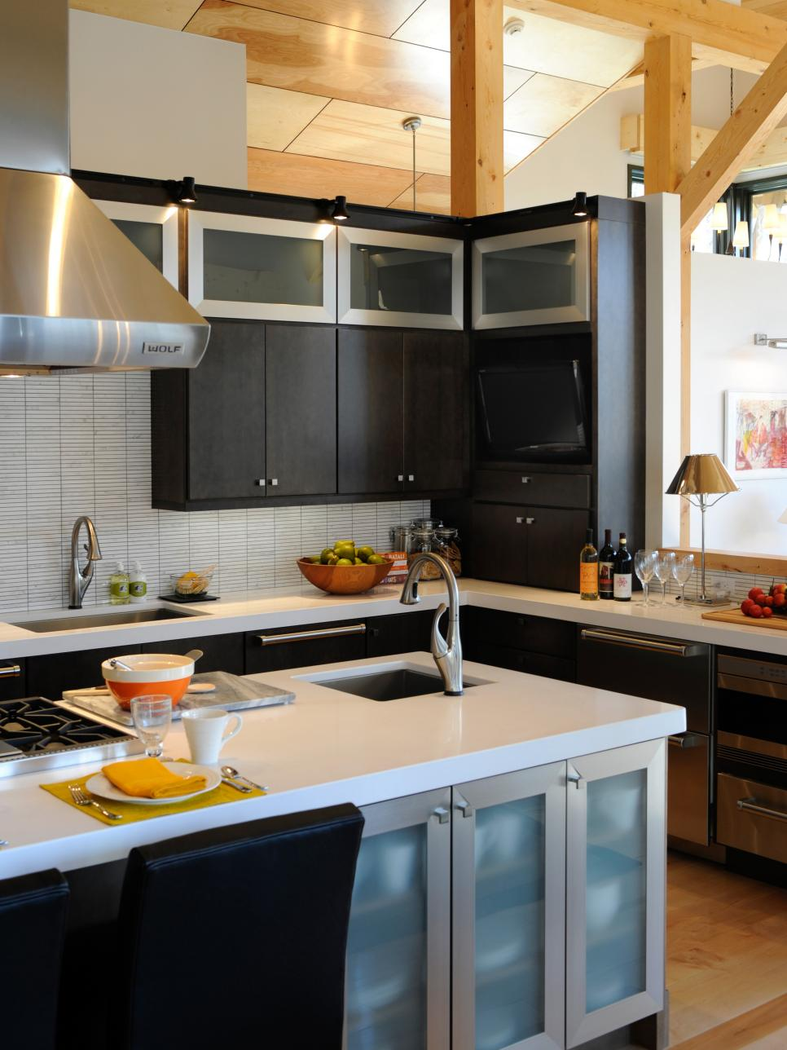
1/ kitench ….> _..........................______ _ _ _

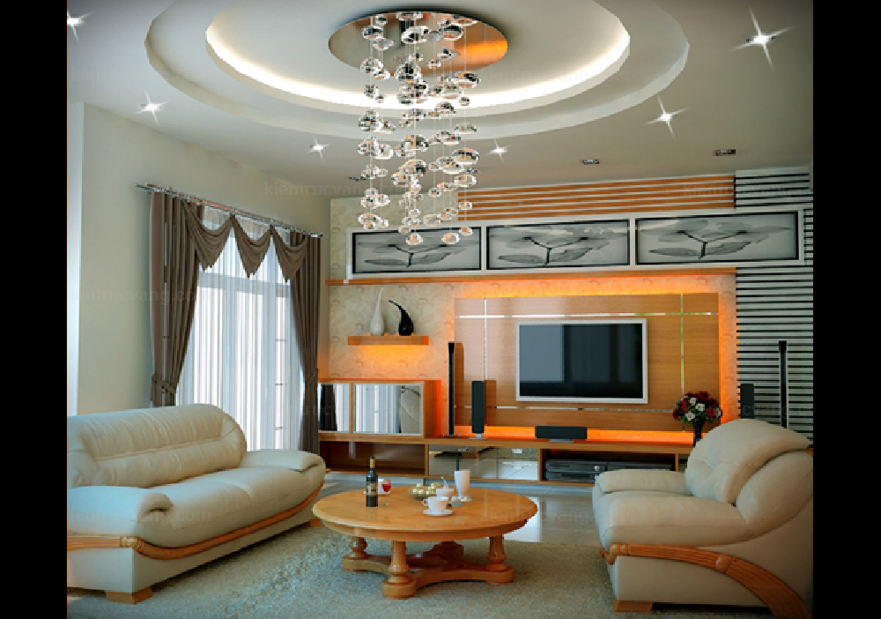
2/ livngi rmoo ….> ……………………

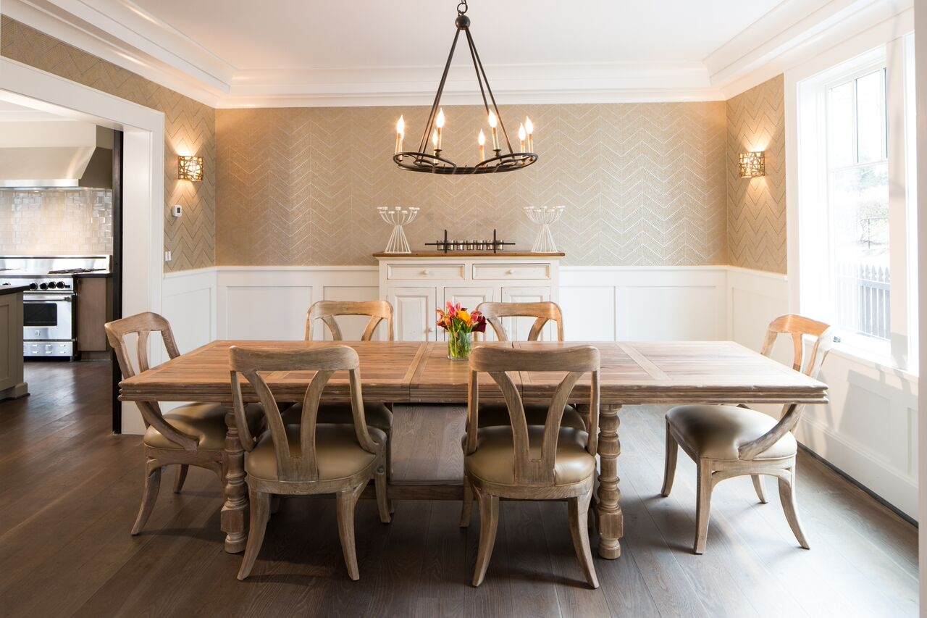
3/ diingn romo….> ……………………

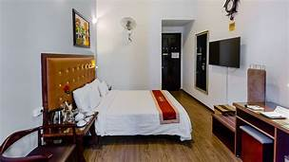
4/bdermoo .…> …………………

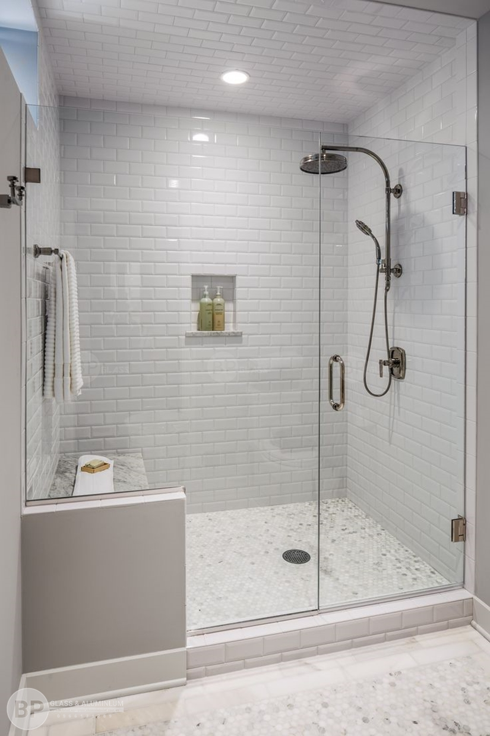
5/bathrmoo ….>…………………..

II/ Write the sentence.
EX: Where/ grandma/ is/ ? …..> Where is grandma?
1/She/ in/ is/ the dining room/ .
…>……………………………………………..
2/ Is/ she/ the kitchen/ in/ ?
…>……………………………………………..
3/Where /Dad and Mom/ ?/ are
…>…………………………………………….
4/they/ Are/ in/ the living room/ ?
…>…………………………………
5/No/, / aren’t/ they/ .
…>………………………………
III/ Write.
is are aren’t no is are bathroom is living room dining room
1/ …Is…..Billy in the bedroom? Yes, he …….
2/………..Lan and Nga in the living room? ........,they aren’t.
3/Are Dad and Mom in the …………………….?
Yes, they are.
4/ ………….Rosy in the ……………….?
Yes, she……………..
5/………….Grandma and Grandpa in the……………………….?
No, they ………………

